**Verified affidavit and complaint by three**

**witnesses to acts of high crimes and**

**treason committed by:**

Charles D. Baker, Lena Pinderton, and

M. Sean Brister.

And we demand their capture and prosecution.

In conformity with**:**

**U.S.A. constitution, Article 3, Section 3 and Constitution of the State of Arkansas, article one, section 14, Treason**: Treason against the United States, shall consist only in levying war against them, or in adhering to their enemies, giving them aid and comfort. No person shall be convicted of treason unless on the testimony of two witnesses to the same overt act, or on confession in open court.

**18 U.S. Code § 2382 Misprision of treason**

Whoever, owing allegiance to the United States and having knowledge of the commission of any treason against them, conceals and does not, as soon as may be, disclose and make known the same to the President or to some judge of the United States, or to the governor or to some judge or justice of a particular State, is guilty of misprision of treason and shall be fined under this title or imprisoned not more than seven years, or both.

And…

**18 U.S. Code § 4 - Misprision of felony**

Whoever, having knowledge of the actual commission of a felony cognizable by a court of the United States, conceals and does not as soon as possible make known the same to some judge or other person in civil or military authority under the United States, shall be fined under this title or imprisoned not more than three years, or both.

**We the three witnesses Vaughn Damon Wilson, William Hugh Wollman, Ricky Dean Sharrah, all State Citizens, witness and attest to the following facts.**

William Hugh Wollman is a natural born State Citizen and God created living soul of the Peoples Republic of California. He not a United States citizen or other legal fiction. And he explicitly retains all of his rights at all times, places and circumstances. He is not subject to admiralty, military, commercial or copyrighted law, including the Uniform Commercial Code (also see UCC 1-308) or any of its nexus including the copyrighted Arkansas code annotated. Nor subject to the courts established by the foregoing. He has not consented to any court, nor has he knowingly and willingly entered any plea. His silence does not waive any rights nor perfect any contracts. And he objects to Charles D. Baker’s efforts to force him into his jurisdiction through threats, duress and coercion. And he objects to his efforts to deny him his constitutional right to a common law court and other due process. And he objects to his threats of jail and contempt, to deny him his right to speak upon his own behalf. And he objects to not being provided with proof of constitutional common law jurisdiction. And he objects to the concealment of any and all bonds. Further, no contract exists and he denies any and all presumed contracts, anyone thinks may exist. He does not waive any of his rights ever.

**On April 12th, 2017 at 1:21 PM.**

We the three witnesses were present at the commercial / admiralty / non-constitutional Crawford County District Court (displaying the gold fringe flag)- Van Buren Division. In fact, the **DUNS number** for the **JUDICIARY COURTS OF THE STATE OF ARKANSAS IS 360709893.**

William Wollman, stepped forward when his name was called. He was asked by Charles D Baker (judge / trier of facts as per the UCC). Charles D Baker asked how he pleads. William Wollman proceeded to say that he was a State Citizen and does not waive his right to a common law court. Before he could finish his statement of non-consent, Charles D. Baker (judge), raised his voice, cut him off from speaking further. Charles D. baker, said “I have heard all of this before.” And continued to threaten Wollman with jail. Wollman never entered a plea into the court and never consented. Charles D. Baker continued to force Wollman into his jurisdiction, and ordered Wollman a trial date of May 10th, 2017 at 1:00 pm.

William Hugh Wollman was never presented with proof of constitutional jurisdiction, common law jurisdiction, any penal bonds, other bonds or any contracts in admiralty or otherwise, that Wollman had signed and consented to.

Later the same day, April 12th, 2017 at 3:11 pm.

Again William Wollman, stepped forward when his name was called. He was asked by Charles D Baker (judge). Charles D Baker asked how he pleads. William Wollman proceeded to say that he was a State Citizen and does not waive his right to a common law court. Again, before he could finish this statement of non-consent, Charles D. Baker (judge), raised his voice, cut him off from speaking further. And again, Baker threatened Wollman with jail. And order a court date on May 10th, 2017 at 1:45 pm.

Charles D. Baker never once stated his or the courts constitutional jurisdiction.

**April 25th, 2017**

I, Vaughn Damon Wilson made public record, William Hugh Wollman’s Demand for discovery, information and jurisdiction, (a non-court document) and also containing a certified mail number, on April 25th, 2017, at the Crawford County Circuit Clerks office. Doc number **2017003785**. It was addressed to Marc McCune and [Lena Pinkerton](mailto:lpinkerton@co.crawford.ar.us) and [Angie Haney](mailto:ahaney@co.crawford.ar.us)

**Crawford County Prosecuting Attorney**

206 South 3rd

Van Buren, AR  72956

And: 1003 Broadway  
Van Buren, AR 72956

Phone: 479-474-5000 Certified Mail Number: 70122210000075124254

It was mailed the same day, and was received on April 27th.

**May 3rd, 2017**

I, Vaughn Damon Wilson also made public record, William Hugh Wollman’s Demand for discovery, information and jurisdiction, (a non-court document) and also containing a certified mail number, on May 3rd, 2017, at the Crawford County Circuit Clerks office. Doc number **2017004100**. It was addressed to M. Sean Brister, J.D., LL.M.

P.O. Box 1451

Alma, AR 72921

(479) 632-2446 Certified Mail Number: 70122210000075124161

It was mailed the same day and received by Brister on May 4th, 2017.

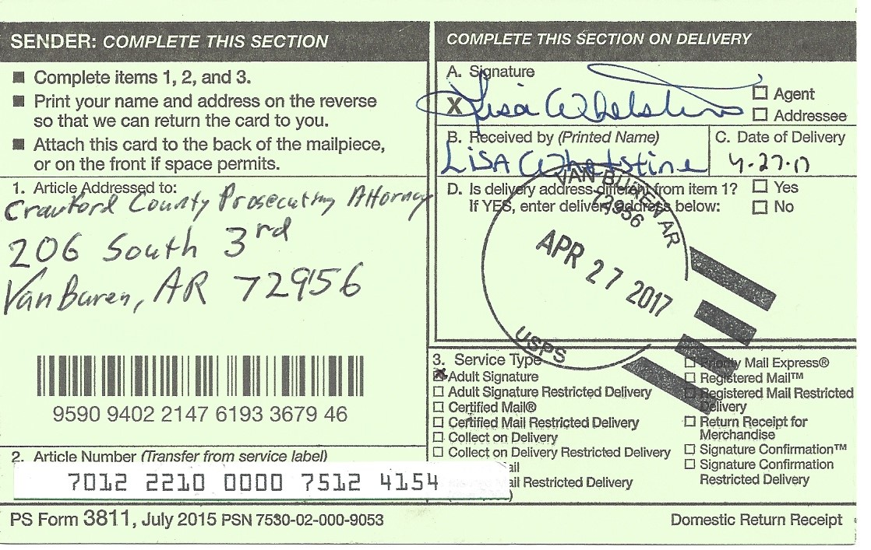

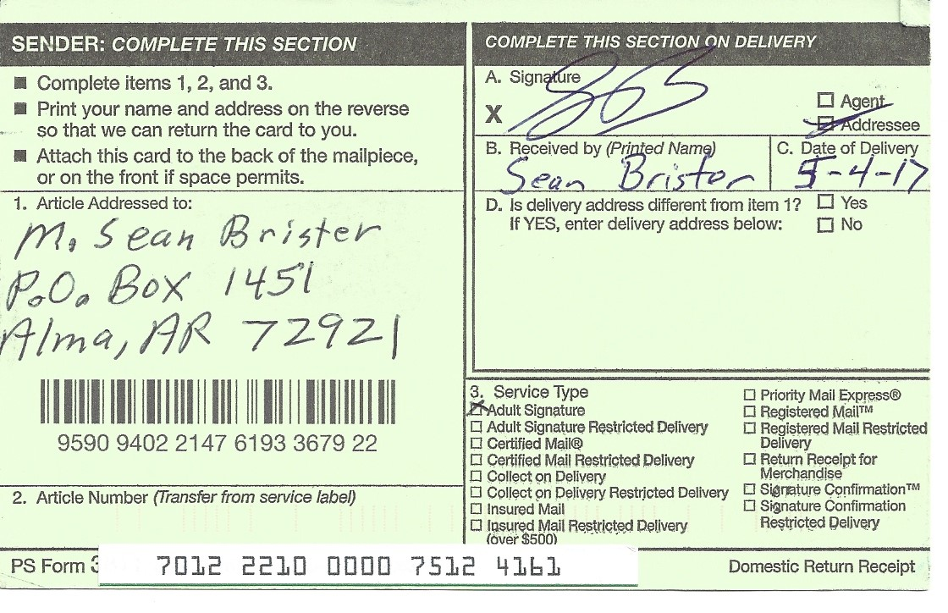

**No answer to proof of jurisdiction questions**

We, Vaughn Damon Wilson, Ricky Dean Sharrah and William Hugh Wollman witness that neither M. Sean Brister, J.D., LL.M., Marc McCune, [Lena Pinkerton](mailto:lpinkerton@co.crawford.ar.us) nor [Angie Haney](mailto:ahaney@co.crawford.ar.us), answered one of the 14 questions challenging jurisdiction. See…

*“Once jurisdiction is challenged, the court cannot proceed when it clearly appears that the court lacks jurisdiction, the court has no authority to reach merits, but rather, should dismiss the action.” Melo v. US, 505 F2d 1026*

*Bindell v City of Harvey*, 212 Ill.App.3d 1042, 571 N.E.2d 1017 (1st Dist. 1991) ("the burden of proving jurisdiction rests upon the party asserting it.").

*"The law requires proof of jurisdiction to appear on the record of the administrative agency and all administrative proceedings." Hagans v Lavine 415 U. S. 533.*

*“Jurisdiction of court may be challenged at any stage of the proceeding, and also may be challenged after conviction and execution of judgment by way of writ of habeas corpus.”*

*[U.S. v. Anderson, 60 F.Supp. 649 (D.C.Wash. 1945)]*

“A judgment rendered by a court without personal jurisdiction over the defendant is void. It is a nullity.” Sramek v. Sramek, 17 Kan. App 2d 573, 576-7, 840 P. 2d 553 (1992) rev. denied 252 Kan. 1093(1993)

*In regard to courts of inferior jurisdiction, “if the record does not show upon its face the facts necessary to give jurisdiction, they will be presumed not to have existed.”  Norman v. Zieber, 3 Or at 202-03*

“Court must prove on the record, all jurisdiction facts related to the jurisdiction asserted.” Lantana v. Hopper, 102 F. 2d 188; Chicago v. New York 37 FSupp. 150

“The law provides that once State and Federal jurisdiction has been challenged, it musts be proven.” Main v Thiboutot, 100 S Ct. 2502(1980)

“Jurisdiction can be challenged at any time,” and “Jurisdiction, once challenged, cannot be assumed and must be decided.” Basso v. Utah Power & Light Co. 395 F 2d 906, 910

“Defense of lack of jurisdiction over the subject matter may be raised at any time, even on appeal.” Hill Top Developers v. Holiday Pines Service Corp. 478 So. 2d, 368 (Fla 2nd DCA 1985)

“Once challenged, jurisdiction cannot be assumed, it must be proved to exist.” Stock v. Medical Examiners 94 Ca 2d 751. 211 P2d 289

“There is no discretion to ignore that lack of jurisdiction.” Joyce v. US, 474 F2d 215

“the burden shifts to the court to prove jurisdiction.” Rosemond v. Lambert, 469 F2d 416

“a universal principle as old as the law is that a proceedings of a court without jurisdiction are a nullity and its judgment therein without effect either on person or property,” Norwood v. Renfield, 34 C 329; Ex parte Giambonini, 49 P. 732

“jurisdiction is fundamental and a judgment rendered by a court that does not have jurisdiction to hear is void ab initio.” In re Application of Wyatt, 300 P. 132;p Re Cavitt, 118 P2d 846

“Thus, where a judicial tribunal has no jurisdiction of the subject matter on which it assumes to act, its proceedings are absolutely void in the fullest sense of the term.” Dillon v. Dillon 187 p27

“A court has no jurisdiction to determine its own jurisdiction, for a basic issue in any case before a tribunal is its power to act, and a court must have the authority to decide that question the first instance.” Rescue Army v. Municipal Court of Los Angeles, 171 P2d 8: 331 US 549, 91 K, ed, 1666m 67 S, Ct, 1409

“A departure by a court from those recognized and established requirements of law however close apparent adherence to mere form in methods of procedure which has the effect of depriving one of a constitutional right, is an excess of jurisdiction.” Wuest v. Wuest, 127 P2d 934, 937.

*Loos v American Energy Savers, Inc*., 168 Ill.App.3d 558, 522 N.E.2d 841(1988)"Where jurisdiction is contested, the burden of establishing it rests upon the plaintiff.”

*Bindell v City of Harvey*, 212 Ill.App.3d 1042, 571 N.E.2d 1017 (1st Dist. 1991) ("the burden of proving jurisdiction rests upon the party asserting it.").

**May 10th, 2017**

We the three witnesses, Vaughn Damon Wilson, Ricky Dean Sharrah and William Hugh Wollman were present at the commercial, non-constitutional Crawford County District Court (displaying the gold fringe flag)- Van Buren Division**.**

On May 10th, 2017 at 1:19 pm, we three were witness to the following. Charles D. Baker called the name of William Hugh Wollman. Wollman came forward. Baker read the charges and asked how Wollman plead. Wollman said “I do not consent”. Baker then assumed jurisdiction without proving or stating jurisdiction. He proceeded through the trial. Every time that Baker addressed Wollman, Wollmans response was “I do not consent”. Baker towards the end sentenced him to 30 days suspended, then one year suspended, then declared him in contempt of court for his answer, that he did not consent. Then sentenced him to 18 days of community service. (slavery/forced labor) Although Wollman never consented to the proceedings. He was cuffed (taken hostage/prisoner) and was denied the counsel of his friends. Note the picture below of William Hugh Wollman cuffed, held prisoner and the gold fringe flag, non-constitutional court.

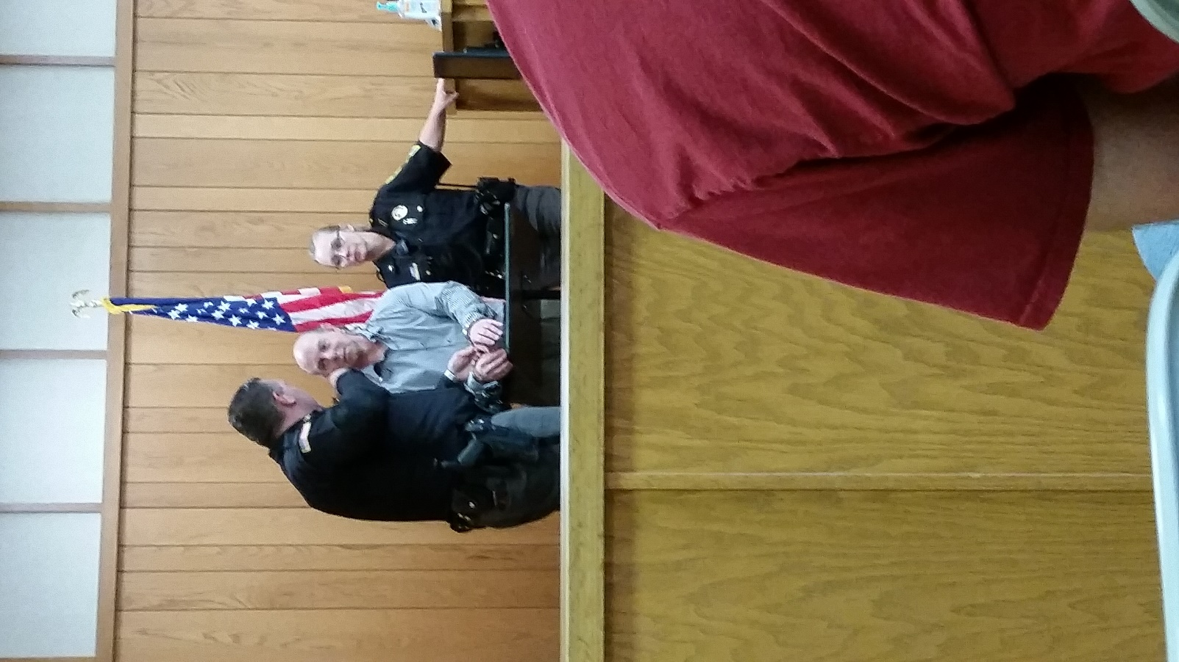

Later that same day May 10th, 2017 at 2:16 pm**.**

Baker again read more charges and asked Wollman how he plead. Wollman plead the fifth (amendment without any counsel present). Baker without proof or statement of constitutional jurisdiction, continued without Wollman’s consent. Each time Baker addressed Wollman thereafter, Wollman’s response was, “I do not consent”. Baker order Wollman to 17 days of community service (slavery/forced labor). Wollman was then transported to the Crawford County jail to be held for 24 hours.

**May12th, 2017**

I, Vaughn Damon Wilson only, attest to the following. In the morning of May 12th, 2017, I called the Crawford County District Court and asked if a fine (ransom) could be paid in lieu of the community service (slavery) ordered by Charles D. Baker. (Buy back from slavery / pay a ransom). I was told that I could pay $1415 dollars, and that they would except cash only. However, lawful money (dollars, gold and silver coin) does not exist. I brought them 1415 Federal Reserve notes which they accepted as proven by the pictures and the receipt below. Therefore, warring against the **U.S.A. constitution article one section ten.**

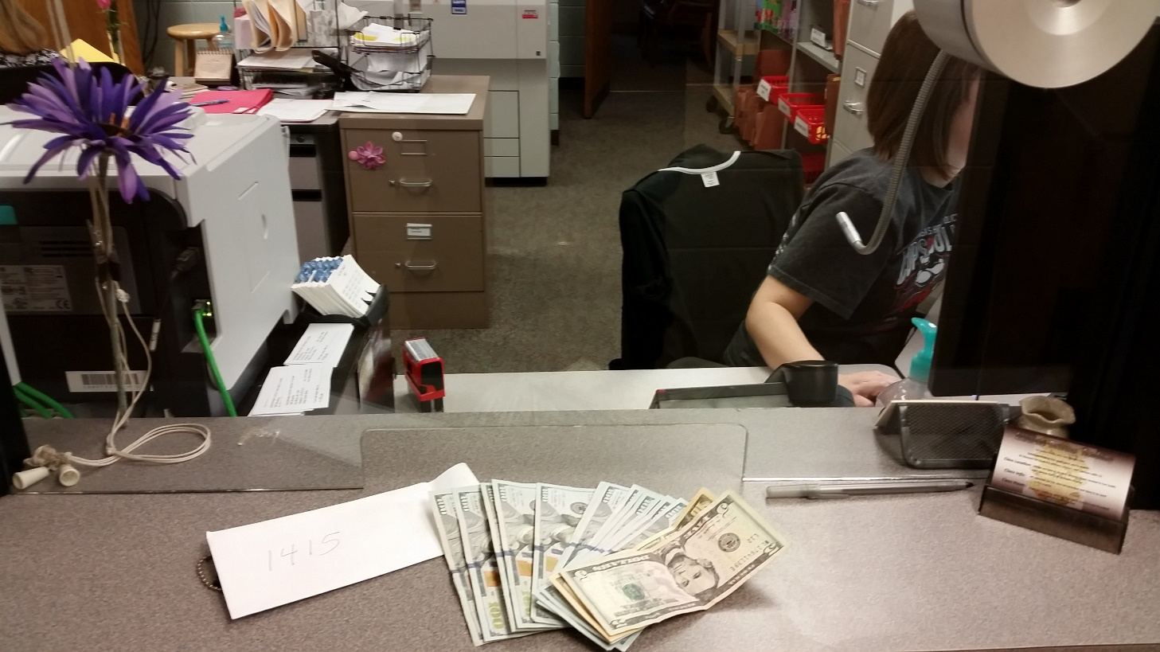

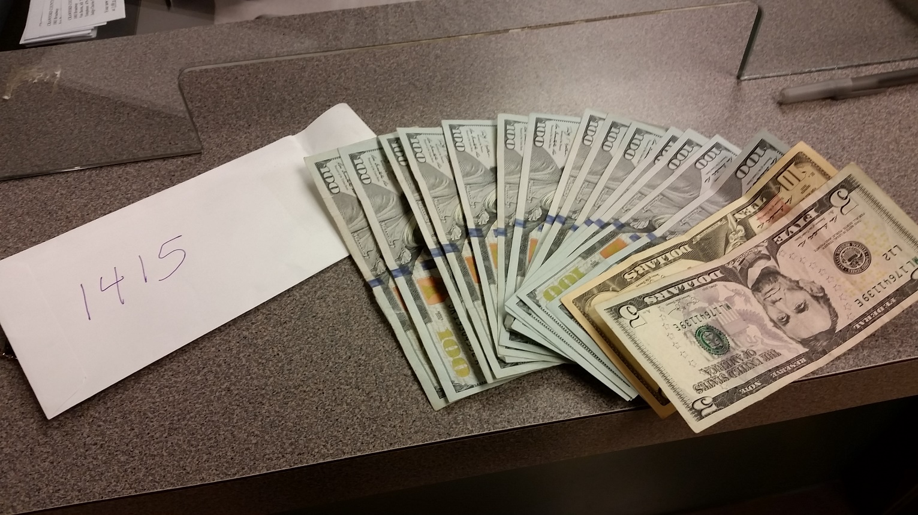

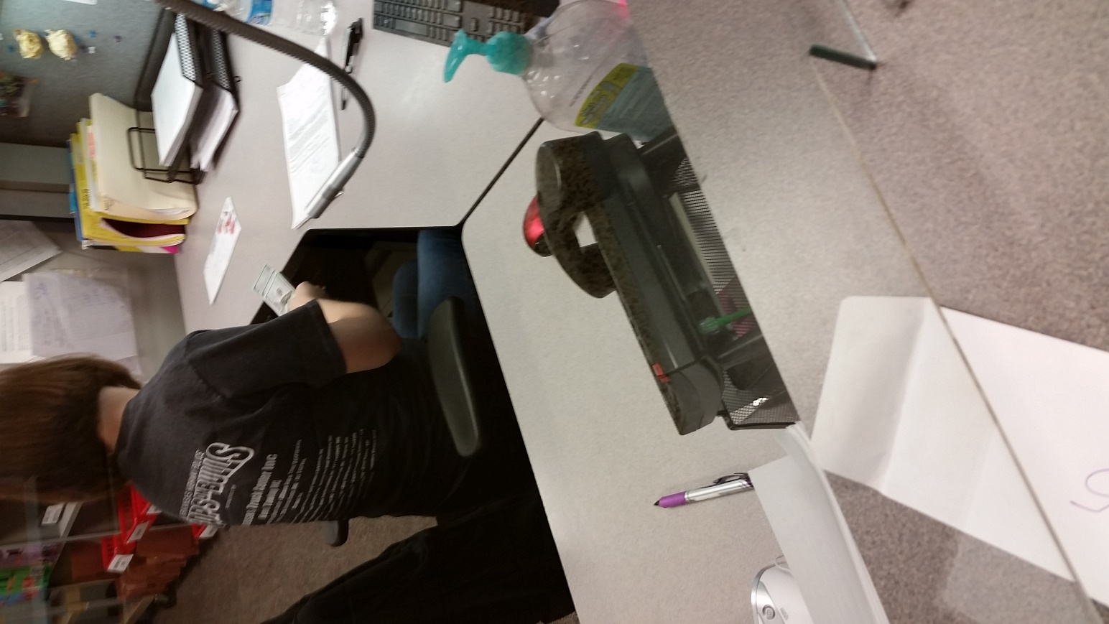

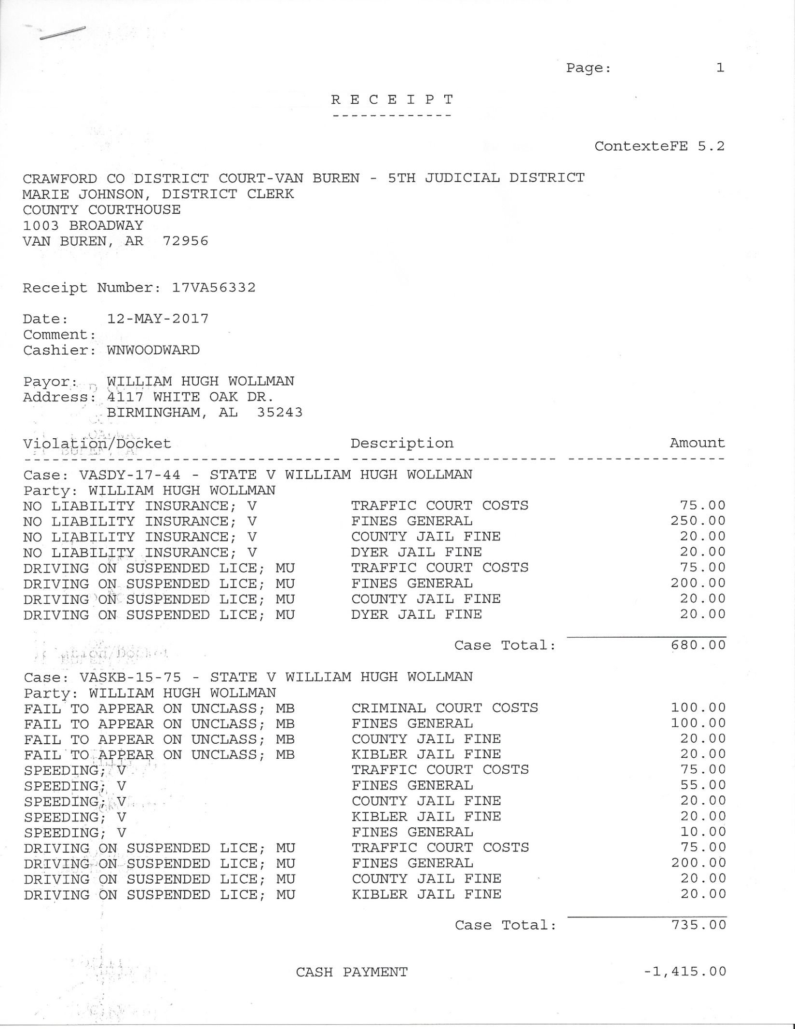

We the three witnesses Vaughn Damon Wilson, William Hugh Wollman, Ricky Dean Sharrah, all State Citizens have witnessed and observed the following facts.

1. **It is a fact: U.S.A. constitution, Article 3, Section 3:** Treason against the United States, shall consist only in levying war against them, or in adhering to their enemies, giving them aid and comfort. No person shall be convicted of treason unless on **the testimony of two witnesses to the same overt act, or on confession in open court.**

Also see…  **Constitution of the State of Arkansas, article one, section 14, Treason.**

1. **It is a fact:** Warring and treason is:

* Tucker’s Blackstone Vol. 1 Appendix Note B [Section 3] 1803 – "If in a limited government the **public functionaries exceed the limits which the constitution prescribes to their powers, every such act is an act of usurpation in the government, and, as such, treason against the sovereignty of the people.”**
* Black’s Law 6th Edition – "**A breach of allegiance to one’s government**, usually committed through levying of war against such government or by giving aid or comfort to the enemy."
* Bouvier’s Law Dictionary 1856- TREASON, crim. law. "**This word imports a betraying, treachery, or breach of allegiance.** 4 Bl. Com. 75."
* Mirriam-Webster Learner’s: “Involved in **war, conflict or disagreement**”

1. **It is a fact:** That an acceptance of a license, does not impose an obligation. See… *"The acceptance of a license, in whatever form, will not impose upon the licensee an obligation to respect or to comply with any provision of the statute or with the regulations prescribed that are repugnant to the Constitution of the United States." W. W. CARGILL CO. v. STATE OF MINNESOTA, 180 U.S. 452 (1901) 180 U.S. 452*
2. **It is a fact:**  That the state cannot convert rights into a privilege. See…*"If the state converts a liberty into a privilege the citizen can engage in the right with impunity" Shuttlesworth v Birmingham , 373 USs 262*
3. **It is a fact:** Federal courts have exclusive jurisdiction in admiralty. Merrick v. Avery, 14 Ark. 370; Doris >'. Mason. 44 Ark. 553.
4. **It is a fact:** That an action in REM cannot be against people. In Latin, in rem means “against or about a thing”. It derives from the word “res”, which means “the thing”.
5. **It is a fact:** The dejure Constitution of the State of Arkansas only establishes common law and equity courts.
6. **It is a fact:** That the Arkansas Code Annotated is copyrighted commercial law / law merchant.
7. **It is a fact:** **That William Hugh Wollman was denied all constitutional due process according to the U.S.A. constitution and the Arkansas constitution.** He was never charged with a common law crime. There was no corpus delicti (injured people), he was denied a common law bail, there was no common law search warrant, there was no common law arrest warrant, there was no grand jury indictment, he was denied a jury, he was denied a common law court, he was denied his freedom, he was falsely arrested and kidnapped, he was denied his choice of counsel (other than a BAR attorney / Esquire / officer of the court), he was subjected to slavery / forced labor, held for ransom and the court did not and does not use gold and to claim is rights secured by both constitutions. Specifically, the right to free speech as guaranteed by the First Amendment. **All of which is waging war against both the U.S.A. and Arkansas constitutions, which is warring against our republic form of government and warring against “we the people” who created it.**

**High Crimes and Treason**

We the three witnesses Vaughn Damon Wilson, William Hugh Wollman, Ricky Dean Sharrah, all State Citizens, witnessed and observed, in the foregoing, the following acts of high crimes and treason committed by Charles D. Baker, Lena Pinderton and M. Sean Brister all in collusion. They have all violated their own oaths of office. And the constitutional threshold for treason has been met.

1. Filing false Charges / stacking charges / falsification of documents. A.C.A. 5-54-121. Tampering with a public record. (1) Makes a false entry in or falsely alters any public record; or
2. Deprivation of rights under color of law. 18 USC 241
3. Conspiracy to deprive rights. 18 USC 242
4. False arrest. A.C.A. 5-11-103. False imprisonment in the first degree.  
   (a) A person commits the offense of false imprisonment in the first degree if, without consent and without lawful authority, the person knowingly restrains another person so as to interfere substantially with the other person's liberty in a manner that exposes the other person to a substantial risk of serious physical injury.
5. Kidnapping. A.C.A. 5-11-102. Kidnapping
6. Treason: That William Hugh Wollman was denied all constitutional due process according to the U.S.A. constitution and the Arkansas constitution. He was never charged with a common law crime. There was no corpus delicti (injured people), he was denied a common law bail, there was no common law search warrant, there was no common law arrest warrant, there was no grand jury indictment, he was denied a jury, he was denied a common law court, he was denied his freedom, he was falsely arrested and kidnapped, he was denied his choice of counsel (other than a BAR attorney / Esquire / officer of the court), he was subjected to slavery / forced labor, held for ransom and the court did not use gold and to claim is rights secured by both constitutions. Specifically, the right to free speech as guaranteed by the First Amendment. **All of which is waging war against both the U.S.A. and Arkansas constitutions, which is warring against our republic form of government and warring against “we the people” who created it.**
7. Piracy. Fraudulent use of admiralty or maritime jurisdiction on dry land, against a State Citizen is robbery ashore, and / or also, to do so in a vessel (Police car) outfitted for the purpose of piracy.

See 18 U.S. Code § 1661 - Robbery ashore. Whoever, being engaged in any piratical cruise or enterprise, or being of the crew of any piratical vessel, lands from such vessel and commits robbery on shore, is a pirate, and shall be imprisoned for life.

Also see 18 U.S. Code § 1654 - Arming or serving on privateers

**We the three witnesses Vaughn Damon Wilson, Ricky Dean Sharrah and William Hugh Wollman, demand that Charles D. Baker, Lena Pinderton, and M. Sean Brister be captured and prosecuted.**

**Nemo me impune lacessit.**

Vaughn Damon Wilson

Signed ______________________ Date: ________ All rights explicitly reserved

Ricky Dean Sharrah

Signed ______________________Date: _________All rights explicitly reserved

William Hugh Wollman

Signed ______________________ Date: _________All rights explicitly reserved

**Notary Public**

State of Arkansas

County of Crawford

On this the ____ day of ________________, _____________, before me,

____________________________________, the undersigned officer, personally appeared

Vaughn Damon Wilson, Ricky Dean Sharrah and William Hugh Wollman, known to me (or satisfactorily proven) to be the person whose name is/are subscribed to the within instrument and acknowledged that he/she/they executed the same for the purposes therein contained. In witness whereof I hereunto set my hand and official seal.

_________________________________

Notary Public

Printed Name: _____________________

My Commission Expires: ___________________